Supporting Improved Local Government Waste Management Services: Report on the Outcomes of dldp and Partners’ Contributions

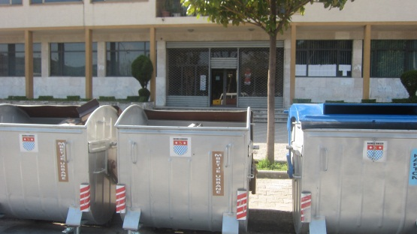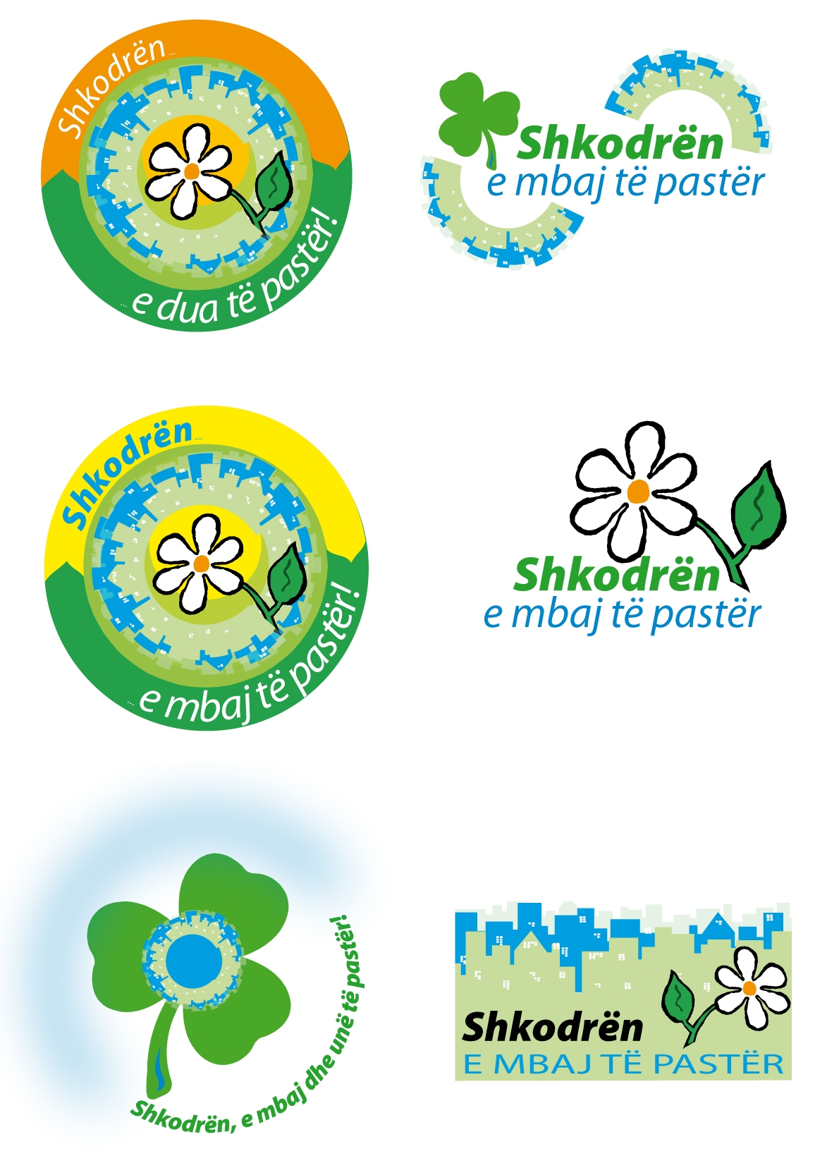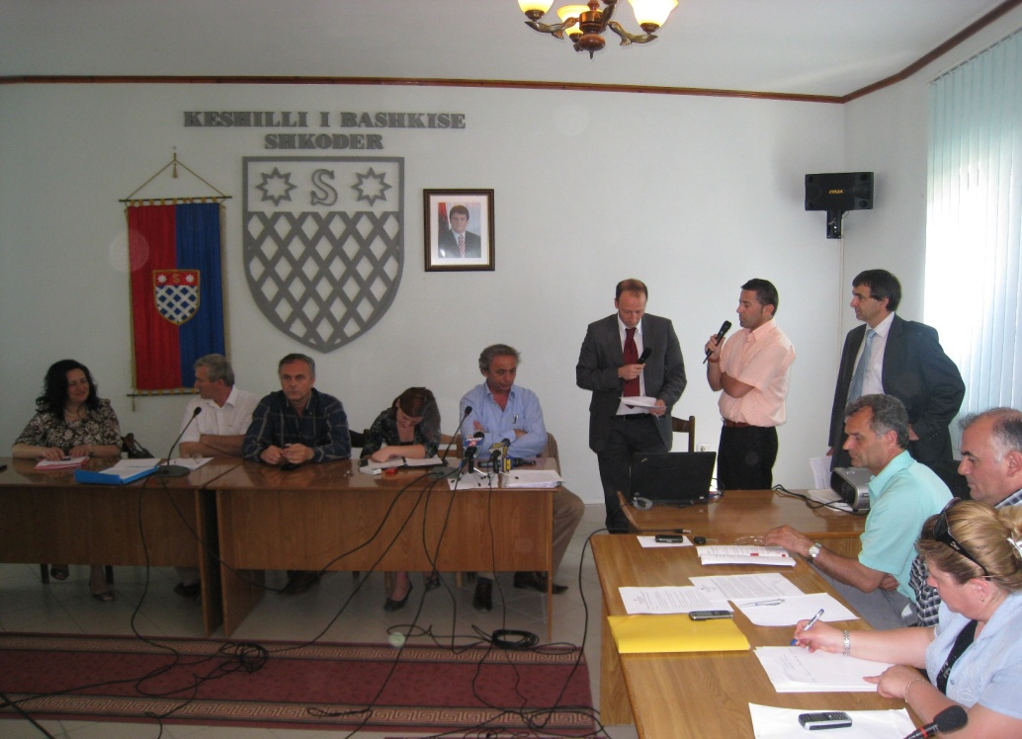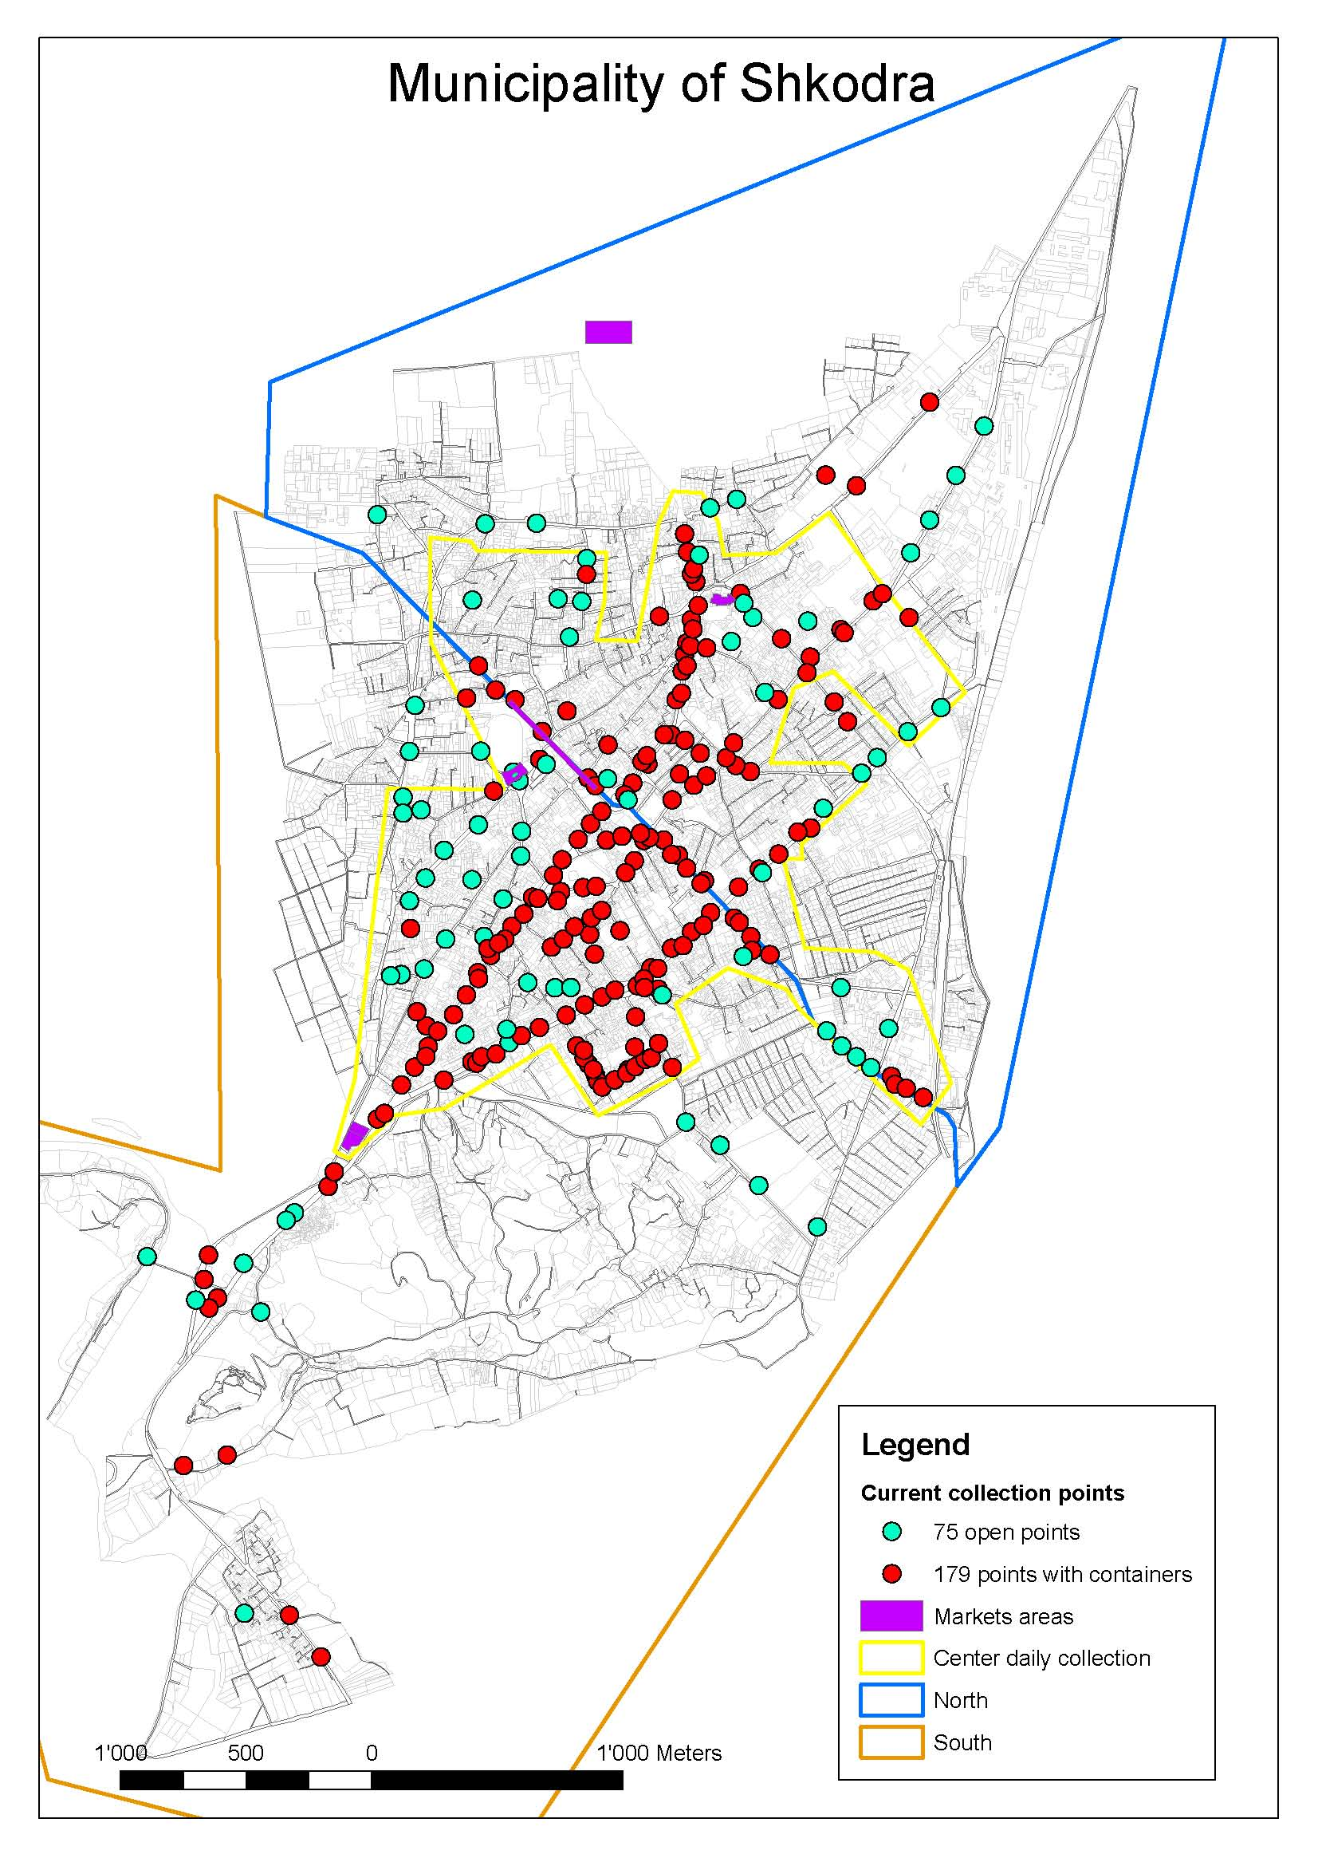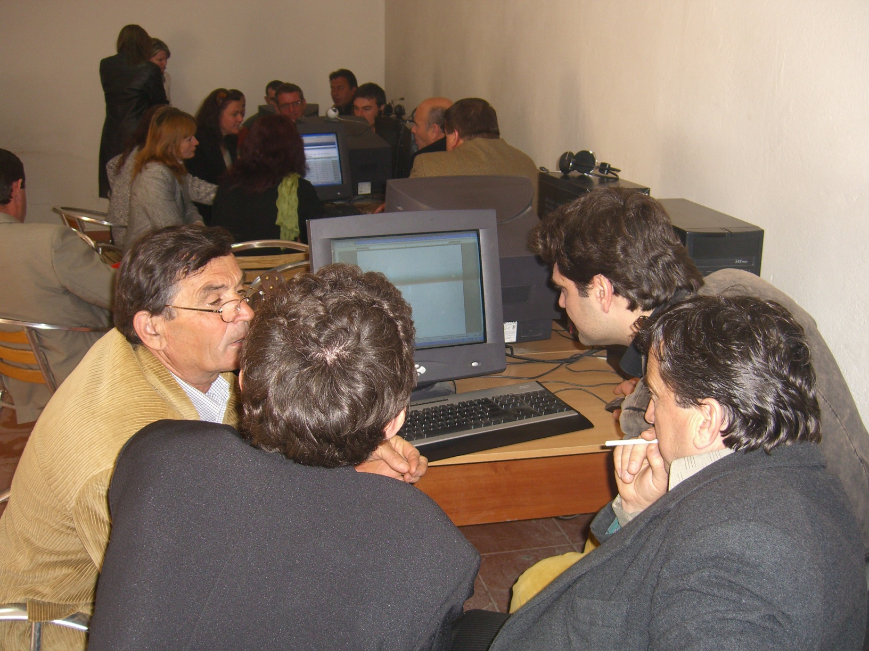

HELVETAS Swiss Intercooperation Albania / dldp
Contributors: Sarah Byrne, Valbona Karakaçi, Jonida Baci, Arben Kopliku

September 2012

1. Objective 5
2. Methodology 6
3. Dldp & Partners’ Contributions to Improved Waste Management Services and Policies 7
3.1. Experience capitalization: Dldp & partners contribute studies and documented experiences and practices to national policy dialogue 8
3.2. Standardised technical guidance: Dldp & partners contribute recommendations, manuals, models and methodologies that give guidance to how to improve waste management service 10
3.3. Capacity building: Dldp & partners build capacities for waste management in specific topics, creating pools of experts and promoting exchange of experience 11
3.4. Technical assistance and funding: Dldp & partners support partner LGUs in planning, implementing and monitoring service delivery with a focus on cost reduction/optimization and service effectiveness 12
3.5. Advice, liaison and coordination: Dldp and partners liaise with various governmental agencies, development partners and service providers to enhance conditions of waste management service delivery, and provide advice to these organisations on demand 14
3.6. Systemic approach: Dldp and partners provide support to this sector in a systemic and integrated way, in the broader frame of implementing decentralisation policy 15
4. Changes Observed in Waste Management Service Delivery 17
4.1. Waste management service delivery is improved in selected partner LGUs 17
4.2. Waste management policy-making is improved and informed by practical experience, good practices and guidance documents 20
4.3. Waste sector partnership is extended at national, regional and local levels 21
5. Alignment with National Waste Management Objectives 24
6. References 25

Introduction and Executive Summary
For the past five years, the Decentralisation and Local Development Programme (dldp) has been providing support in the waste management sector to local governments in Northern Albania, with the support of Swiss and Albanian partner organisations. With the new Albanian National Waste Management Strategy approved in late 2011, there is now a clear impetus and direction for activities in this field. In this context, dldp decided to engage in a “stocktaking” initiative, to consult with a group of key stakeholders and its partners about what changes have been achieved during this time. The initiative, documented in this report, seeks to answer the following three questions:
- What do partners (dldp partner LGUs, the national government, other national partners and other LGUs) do differently in the field of waste management (partly as a result of dldp’s efforts)?
- How are dldp supported activities aligned with national-level objectives in the field of waste management?
- What is the cost-benefit relation of certain specific achievements of dldp?
For dldp and its partners, support to waste management is one way, and a very concrete one, to support local government units (LGUs) in improving the public services they offer to citizens. Improved waste management leads to better environmental conditions (for example cleaner streets and rivers), but also to improved accountability between local government and citizens, improved capacities of LGU staff to plan, implement and monitor service delivery, and opportunities for cost savings through regional or inter-LGU approaches to service delivery. The experiences made and lessons learned by dldp partner LGUs are also of great interest to other LGUs and national stakeholders searching for practical and efficient solutions.
Rather than focusing on the complete “causal” results chain, this methodology of this report takes a snapshot approach to monitor dldp contributions and outcomes (changes at partners’ level) in several areas of key project activities related to waste management. The information in this report is based on ten interviews with expert stakeholders, a literature review of existing studies and reports, as well as the proceedings of the recent national conference “Local and Regional Waste Management in Albania: Challenges and Learnings in Planning and Implementation”. The cost/benefit data presented in this report are derived from dldp’s budget monitoring as well as financial management data collected from partner LGUs.
The results of this study are presented in the table on the following page. The column on the left is a list of the main contributions dldp and partners have made to improving waste management services, as identified through expert interviews and a literature review. The column on the right is a list of the changes at the partner level that have been observed by the experts we interviewed. These changes are due to a number of factors, a significant one being the contributions made by dldp and partners. This report follows the logic of the outcome model, in which project’s contributions combine with a variety of other factors to produce or inspire changes among the project partners (in this case LGUs in Shkodra and Lezha, as well as national actors). Thus the combination of the contributions in the left column is, the report shows, significant in leading to the changes that have been observed in what partners do and how they do it (given in the column in the right).

Dldp and Partners’ Contributions to Improving Waste Management Services & Policies |  | Changes Observed in Waste Management Service Delivery at the Level of Dldp Partners (LGUs in Shkodra and Lezha and national actors)
Experience capitalization: Dldp & partners contribute studies and documented experiences and practices to national policy dialogue  - Standardised technical guidance: Dldp & partners contribute recommendations, manuals, models and methodologies that give guidance to how to improve waste management service  - Capacity building: Dldp & partners build capacities for waste management in specific topics, creating pools of experts and promoting exchange of experience  - Technical assistance and funding: Dldp & partners support partner LGUs in planning, implementing and monitoring service delivery with a focus on cost reduction/ optimization and service effectiveness  - Advice, liaison and coordination: Dldp and partners liaise with various governmental agencies, development partners and service providers to enhance conditions of waste management service delivery, and provide advice to these organisations on demand  - Systemic approach: Dldp and partners provide support to this sector but in a systemic and integrated way, in the broader frame of implementing decentralisation policy |  | - Waste management service delivery is improved in selected partner LGUs  - LGUs have more information about the principles and possibilities of waste management  - LGUs implement concrete improvements in waste management service delivery  - LGUs consider new, innovative, more efficient and ecological options for waste management  - LGUs are more responsible for implementing waste management services and proactive in seeking solutions  - Other LGUs (beyond dldp partner LGUs) become more aware of the issue of waste management and are inspired by the good practices of LGUs in Skohdra and Lezha to address the issue themselves  - Waste management policy-making is improved and informed by practical experience, good practices and guidance documents  - Waste management policy-making is informed by concrete proposals for sustainable and affordable solutions to implement the national strategy at local and regional level  - Waste management policy-making is a participatory process in which LGU voices are heard  - Identified evidence based national waste management policy bottlenecks and challenges are addressed by the central government  - Waste sector partnership is extended at national, regional and local levels  - At the national level, a multi-sectoral approach to waste management is initiated  - Lobbying to defend local interests in designing national policies is undertaken  - At the local level, an atmosphere of trust between LGUs conducive to engaging in mutually beneficial inter-LGU waste management initiatives is generated  - Incentives to LGUs to engage in partnership to tackle waste management issues are provided  - The partnerships that dldp and partners have facilitated have pushed LGUs and other actors to be proactive and committed to seeking change  - Albanian experiences have become a regional reference for neighbouring countries facing similar challenges

In the second section of this report the objectives for the study are outlined, followed by a description of the methodology in the third section. The fourth section is devoted to description of a variety of the contributions made by dldp and partners. The fifth and final section explains the changes observed at partners’ level with respect to waste management.
Cost-benefit elements
In addition to the analysis of the contributions of dldp and partners and the changes that have resulted, selected contributions/activities that have been important factors in achieving the reported changes are presented through a reporting of the relationship between costs and benefits. Given the available time and resources, as well as the kind of presented results/change a thorough cost-benefit analysis of dldp’s whole waste management portfolio is beyond the scope of the present stocktaking exercise, and the picture painted by the cost-benefit data we present here must be understood as having significant limitations.

Objective
Waste management has become a priority policy area for the Albanian government, linked to an increased awareness about the social, economic (tourism, economic development) and environmental aspects of the waste sector. A new National Waste Management Strategy and a National Waste Management Plan were approved in 2011, giving impetus and direction for activities in this field.
For the past five years, the Decentralisation and Local Development Programme (dldp) has been providing support in the waste management sector in Northern Albania, with support of Swiss experts from CSD and Albanian experts (co-plan, URI, REC, individual experts). In this context, dldp decided to engage in a “stock-taking” initiative, to consult with a group of key stakeholders and its partners about what changes have been achieved during this time. On the basis of this consultation, the first objective of this report is to document the contributions made by dldp and its partners in the field of waste management, and in particular to assess the changes that have come about as a result of these contributions. The second objective is to conduct a simplified cost-benefit analysis of selected cases/contributions within the overall support of dldp to the waste sector in Albania for illustration purposes
The report seeks to answer the following three questions:
- What do partners (dldp partner LGUs, the national government, other national partners and other LGUs) do differently in the field of waste management (partly as a result of dldp efforts)?
- How are dldp supported activities aligned with national-level objectives in the field of waste management?
- What is the cost-benefit relation of certain specific achievements of dldp?
For dldp and its partners, support to waste management is one way, and a very concrete one, to support local government units (LGUs) in improving the public services they offer to citizens. Improved waste management leads to better environmental conditions (for example cleaner streets and rivers), but also to improved accountability between local government and citizens, improved capacities of LGU staff to plan, implement and monitor service delivery, and opportunities for cost savings through regional or inter-LGU approaches to service delivery. The experiences made and lessons learned by dldp partner LGUs are also of great interest to other LGUs and national stakeholders searching for practical and efficient solutions. Thus activities in the waste management sector contribute to both of the outcomes established for dldp second phase:
- Outcome 1: Municipalities and communes in Shkodra and Lezha Qark have improved their governance structures, capacities and selected local public services.
- Outcome 2: Good practices are shared at national level through strengthened associations, thus impacting law and policy-making and their implementation at national level
In the following, we will assess the extent to which these changes, and other significant changes, have been observed by the group of local and national experts interviewed for this report.

Methodology
The methodology used for preparing this report is based on the guidance provided by the UNDP publication “Outcome Level Evaluation”, recommendations given in dldp’s mid-term evaluation for the second phase, as well as consultation with a group of experts and the project staff. The monitoring methodology developed for this report serves to complement the project’s regular monitoring system and this is not fully comprehensive of all levels of the results chain from input to impact. Rather it focuses on a snapshot approach to monitor dldp contributions and outcomes (changes at partners’ level) in several areas of key project activities. For the purposes of this report, we understand outcomes as follows:
“Outcomes describe the intended changes in development conditions that result from the interventions of governments and other stakeholders, including international development agencies … They are medium-term development results created through the delivery of outputs and the contributions of various partners and non-partners. Outcomes provide a clear vision of what has changed or will change globally or in a particular region, country or community within a period of time. They normally relate to changes in institutional performance or behaviour among individuals or groups. Outcomes cannot normally be achieved by only one agency and are not under the direct control of a project manager.”
The final sentence is important to understating the framing of this report – outcomes are not what dldp delivers, but rather the changes that happen at the level of project partners on the basis of dldp contributions as well as a variety of other factors. While we cannot rigorously establish that certain changes at are the direct result of services delivered by dldp (particularly changes at the national level, due to the complexity of the national arena), our aim is to establish that dldp support and activities have contributed to this change.
The information in this report is based on interviews with the local and national level experts as well as international ones knowledgeable about dldp’s activities in the field of waste management and the changes they have inspired. Additional data came from a literature review of existing studies and reports (several of which were themselves based on interview or focus group discussion data), as well as the proceedings of the recent national conference “Local and Regional Waste Management in Albania: Challenges and Learnings in Planning and Implementation”. All of the interviews and secondary data were analysed for key contributions and key outcomes or changes. This report covers the period 2007-2012 and with a particular focus on activities in dldp’s second phase (2010-present).
The cost and benefit data presented in this report are derived from dldp’s budget monitoring as well as financial management data collected from partner LGUs. Costs and benefits have not been thoroughly assessed at the level of outcomes but mainly at the level of contributions leading to reported changes, as we understand these changes in partners’ perspectives and behaviours to be both a) generally not quantifiable (unless by proxies that may not be representative of the most significant changes) and b) due to a variety of factors beyond the control and influence of dldp such that establishing a clear attribution solely to costs incurred by dldp is not rigorous. Rather, selected contributions/activities that have been important factors in achieving the reported changes are presented through a reporting of costs and benefits. Given the available time and resources, a thorough cost-benefit analysis of dldp’s whole waste management portfolio is beyond the scope of the present stocktaking exercise, and the picture painted by the cost-benefit data we present here must be understood as having significant limitations. As dldp is the only programme in Albania delivering such assistance at the local level, the comparative basis for such a study does in any case not exist. Therefore this report remains primarily qualitative, focussed on outcomes, with certain cost benefit indications and trends. Indeed, the qualitative data that we present about the changes that have occurred at the level of dldp’s partners tells a very convincing story in and of itself.

Dldp & Partners’ Contributions to Improved Waste Management Services and Policies
In 2007 dldp started to support several of its partner LGUs in improving their waste management services, starting with Fushe Arrez and Shkodra, and by 2010 this support had been expanded to a group of 12 LGUs. Today, dldp is supporting 12LGUs in the field of waste management, as well as undertaking various activities with national-level partners. The support provided through dldp was broad and addressed different areas of concern for LGU partners, including financial & technical support, capacity building and policy influence. Dldp’s support in particular has been assessed as being both effective and sustainable due to its balance of both “soft” and “hard” projects (i.e. support to the development of waste management plans and support to the implementation of different components of these plans). Since 2010, the scale and scope of dldp & partners’ activities have increased considerably – to the extent that at the recent national conference “Local and Regional Waste Management in Albania” LGUs in Shkodra and Lezha regions were assessed as being leaders in piloting innovative and cost-effective solutions for improving waste management services.
Dldp and its partners have supported improved waste management service delivery through different contributions. In this section, this support is grouped around six different contributions:
- Experience capitalization: Dldp & partners contribute studies and documented experiences and practices to national policy dialogue
- Standardised technical guidance: Dldp & partners contribute recommendations, manuals, models and methodologies that give guidance to improve waste management service
- Capacity building: Dldp & partners build capacities for waste management in specific topics, creating pools of experts and promoting exchange of experience
- Technical assistance and funding: Dldp & partners support partner LGUs in planning, implementing and monitoring service delivery with a focus on cost reduction/ optimization and service effectiveness
- Advice, liaison and coordination: Dldp and partners liaise with various governmental agencies, development partners and service providers to enhance conditions of waste management service delivery, and provide advice to these organisations on demand
- Systemic approach: Dldp and partners provide support to this sector but in a systemic and integrated way, in the broader frame of implementing decentralisation policy
Many of the contributions overlap between one or another heading, since dldp takes an integrated approach, which also makes it difficult to conduct a cost-benefit analysis for each contribution. As an expert interviewed for this report explained: “The main contribution (of dldp) is in bringing all the actors involved in this sector around the same table, facilitating discussions and at the same time bringing expertise and positive examples which help LGUs start and improve the service (of waste management).” Thus some contributions are mentioned under different headings and cross-referenced to the extent possible.

Experience capitalization: Dldp & partners contribute studies and documented experiences and practices to national policy dialogue
A significant component of dldp and partners’ contributions towards improving the conditions for waste management in Albania consists in providing evidence, in the form of studies or documented experiences and practices. These serve to inform a national and international policy debate with very concrete and useful inputs, raising awareness on the practical issues faced by LGUs in various fields as well as the good practices they have developed. The following are a selection of key contributions.
Studies: When making recommendations to its LGU partners, dldp’s approach is to make a thorough study of the various options in order to ensure that it provides the best advice. A significant recent study is entitled: “Optimisation model of waste collection and transport in Albania”. This study assesses the costs of different waste collection and transport methods. It compared the reference scenario (each LGU has its own trucks and collects its waste individually) with options for reducing costs, including inter-LGU waste management planning and the implementation of waste transfer stations used by several LGUs. The overall cost reduction between the reference scenario and the optimized ones is about 40%. This study thus provides a strong and evidence based-argument in favour of inter-LGU cooperation in the field of waste management planning and collection. In this sense it also represents a contribution to the implementation of the Albanian National Strategy on Waste Management as it identifies the most efficient and feasible scheme for waste collection and transport from a regional and inter-LGU perspective, which are considered by the Strategy to be the most efficient in terms of cost and environmental protection. The study was presented in the national conference “Local and Regional Waste Management in Albania-Challenges and Learning in Planning and Implementation” (Tirana, July 2012), where it attracted considerable interest.Thus SELEA, the EU mandated programme for elaboration of regional waste area plans, has shown interest to replicate the same methodology in calculating the regional waste management costs throughout Albania’s regions.
Another important study was a baseline study of partner LGUs conducted by dldp in 2010 and presented at the IFC/SECO conference in March 2012. The baseline study assessed a number of fields of local governance, including waste management service provision and came up with useful findings on the extent and quality of services available in partner LGUs, the support provided from dldp, as well as their perceptions on how to continue improving these services. The relevance of these findings was confirmed by the National Waste Management Strategy (2011), which included similar findings about the achievements, challenges and potentials of LGU waste management services.
Finally, the business plan for the recycling station in Lezha (2011), supported by dldp, enabled the involvement of national private actors like the Albanian Recycling Association to join in a public-private partnership. According to this study, the local budget for waste collection will be reduced by 10% and the quantity of dumped waste with 1000 tons. The pilot experience that was implemented based on this business plan has been recognized by national authorities as an innovative solution and has been shared at a national conference “Waste Management: From Awareness to Practical Action”, organized by the Dutch and German Embassies and KfW in Albania.
Good practice documentation: dldp and partners have also contributed the documentation of case studies of best practices – practices which were shared in a national conference as well as through the project’s website. Two of the sixteen good practices documented were from the waste sector: differentiated waste collection in the Municipality of Lezhe and urban waste management in the Municipality of Fushe Arrez. The brochure documenting the best practices is widely distributed in English and Albanian versions both nationally and internationally, for example at the NALAS Nexpo Fair in 2011. These documented good practices also feed into other contributions of dldp, such as the manual and training curricula outlined in section 4.2 below.
Monitoring: In addition to conducting studies and documenting good practices, dldp and partners maintain a regular monitoring of their activities in the field of waste sector service delivery, in order to document progress, achievements and challenges, and on which basis to formulate lessons learned. Service evaluation and monitoring is part of the capacity building package that dldp delivers to its partners. Dldp and partners are in a position to share concrete lessons learned on the various waste sector service delivery initiatives because regular monitoring provides both information and opportunities for analysis. An early example was the monitoring of the waste management plan of Fushe Arrez, supported by dldp and partners. The waste management plan of Fushe Arrez was approved at the end of 2007. After one year of implementation an assessment was carried out. Lessons learnt from this assessment showed that converting waste service from a private to a public service might be the right path for small LGUs, whereas the household revenues were increased from 0 to 60% due to a participative service planning process. Both findings helped dldp in identifying the right approach in supporting LGUs in improving public services. In addition to Fushe Arrez, Guri i Zi and Dajç (2009-2010) were supported through different co-financing projects during phase 1 of dldp. Two LGUs developed new waste management plans and made investments in order to implement the plans. In January 2012 a rapid assessment was carried out to identify results, main challenges and lessons learnt. The results of monitoring the implementation of these plans show some discrepancies between plan and reality as well as problems in funding the service, but also success stories, such as the fact that the service is delivered regularly and the territory covered is increased from year to year. These learnings have been fed back into dldp’s implementation strategy for the sector as well as in the national policy (necessity of a national environmental fund, inter-LGU cooperation for cost reduction, necessity of accurate data on volume of waste calculation etc.).
Events: dldp has been active in participating at and facilitating various events, particularly at the national level, through which the experience of dldp and its partners contributes to the national policy dialogue. As linkages and opportunities for interaction between representatives of local and national government, particularly more remote local governments, can be weak or unsystematic, events that bring local and national decision-makers together at the same podium are important in stimulating dialogue. Highlights include national conferences specifically on the topic of waste management. The first conference, organised by IFC-SECO in March 2012, aimed to improve waste management services and practices in Albania by laying the groundwork, opening the discussion and building capacity to facilitate private-sector participation and investment in the municipal waste management projects (waste disposal, treatment and collection). Dldp contributed to this event through sharing the approach to waste management it has developed with partners on waste management, as well as sharing lessons learned in two cases (Shkodra and Lezha municipalities) facilitated by dldp.
The second key highlight was the recent national conference “Local and Regional Waste Management in Albania: Challenges and Learnings in Planning and Implementation” organised in the frame of dldp by the Ministry of Interior (MoI) and the Swiss Agency for Development Cooperation (SDC), which gathered over 100 experts and policy makers from local, regional and national authorities (including 3 ministries), practitioners, international and national experts and the private sector. The objective of the conference was to facilitate an exchange of experiences and tools in applying and implementing the national waste management policy framework at local and regional level. The experience of dldp and its partners was very prominent, represented through presentations of experiences on waste management at local and regional level. In addition, a waste management manual for LGUs was introduced and shared (See 3.2), as well as the above-mentioned study for the optimization of the collection and transport at LGU and regional level. The conference was widely reported in the national media. Through its participation at these high-level conferences, dldp has ensured that the practical challenges (and potentials) for LGUs in implementing the national waste strategy and plan are on the national agenda.
In addition to these two conferences specifically oriented to the waste sector, dldp and partners shared their experiences in improving waste service delivery at other events. For example, on February 10th, 2009 dldp organized a national conference “Supporting Decentralisation and Local Development, the Swiss Experience in Shkodra Region”. The conference was a milestone during phase 1 of DLDP, providing DLDP and its partners an important platform to present and discuss key results, good practices and lessons learned. A set of capitalization and dissemination material was developed and broadly distributed. With respect to waste management, the experiences of 4 LGUs (even before the approval of the national strategic documents) laid the ground for policy discussions based on concrete experiences as well as serving as a bridge to activities in dldp phase 2.

Standardised technical guidance: Dldp & partners contribute recommendations, manuals, models and methodologies that give guidance to how to improve waste management service
A second contribution of dldp to improved waste management services is its support to the development and dissemination of standardised technical guidance, based on the experience of dldp and partners, as well as other experts. These guidance documents distil the lessons learned by dldp and partners through the process of implementing different activities. Through developing standardised guidance, dldp and partners aim to improve both their own efficiency and effectiveness, as well as that of other interested LGUs.
Manual on “Planning Local Waste Management”: The National Waste Management Strategy orients implementation activities around four pillars: planning, education, resourcing and legislation. The need to develop regional and local level Waste Management Plans is stated as an urgent priority. Dldp and partners have made a significant contribution to the provision of standardised technical guidance available in the waste management sector as well as in laying the ground for national plan implementation through the development, publication and dissemination of the manual “Planning Local Waste Management”.
The manual is a practical tool for LGUs in Albania to plan, organize and implement LGU waste management schemes. It manual covers all relevant aspects related to waste management, including planning, organization and management, rules and contracting, collection and transport system, cost calculation and tariffs, treatment and disposal, monitoring and controlling, awareness and information. Reflecting on experiences and practices from across Albania, the manual combines these with an introduction to the basics and principals of waste management as well as information on Albanian and EU-level regulations. The manual emphasises practical examples and lessons learnt so that learnings can more easily be transferred into practice. The manual responds to a need voiced by LGUs – with the national strategic planning documents finalised, the next step envisaged was the preparation of local waste management plans. The manual is designed to support this process, and draft versions were consulted with key experts. It was presented and officially launched at the recent conference “Local and Regional Waste Management in Albania Challenges and Learnings in Planning and Implementation”. Conference participants found the manual to be highly relevant and an excellent working instrument for LGUs in Albania. Further, they agreed that further dissemination should be organized and promoted: proposals for doing so are currently under discussion. The manual was highly commended by the experts interviewed for this report, who consider it a positive and serious document, the right document at the right time, and even “the best material that I have seen during these years that I have been dealing with waste management.”
Training curricula on waste management: In addition and complement to the above-mentioned manual, dldp and partners are piloting a four module training curriculum on waste management. This curriculum is based on trainings provided to the inter-LGU working group on waste management established with dldp’s 12 partner LGUs working with dldp in the waste sector (see section 4.3 below). Based on this experience, as well as the needs identified during the baseline study on local governance (see section 4.1 above), four different topics were identified and the contents elaborated together with LGU experts and service provider organisations. The four modules are on: 1. Planning waste collection, storage and transport; 2. Waste minimization; 3. Funding waste management 4. Organization of waste management (rules, regulations, information). The training curriculum contains both theoretical and practical parts, including case studies building on the practical experiences of dldp and partners. Proposals for making this training curriculum available at a national scale are under discussion, as well as, more broadly, how to proceed with much needed capacity development in this sector in a systematic and sustainable way.

Capacity building: Dldp & partners build capacities for waste management in specific topics, creating pools of experts and promoting exchange of experience
Capacity development is an important part of dldp’s support package, where it is paired with technical assistance and specific infrastructural investments. Particularly in the waste sector, capacity building has been identified as an area where significant improvements and support are needed. An interesting specificity of dldp’s capacity building strategy is its support to peer learning through the inter-LGU group of experts established for each of the main areas of support, including also waste. In general, according to a report on dldp’s support in this sector, even “advanced” LGUs have benefitted from dldp’s capacity building support, which allowed them to systematise and update their knowledge and to learn more about specific topics such as costing waste services, recycling, etc.
Study visits: dldp and partners have organised a series of study visits in Montenegro and one in Switzerland in order to expose LGU partners to various aspects of waste management service delivery and to allow for exchange with LGU experts in other localities. For example, in 2008 a study visit was organised to Ulcinj (Montenegro) for staff of Velipoja LGU. During this study visit the newly elected mayor of Velipoja and the staff of the LGU administration had the chance to meet colleagues from the administration of Ulcinj who are responsible for similar topics, as well as representatives of private businesses and of the communal waste and water company. The focus of the study visit was on was beach area management: how to keep the beach area clean, relationship with private businesses etc. Further study visits to Montenegro, on waste separation and recycling, took place in 2009 and in 2012. During the latter visit, dldp and its partners were invited to participate in the international conference “Waste is compost, raw material and energy”. In 2010, a study visit to Switzerland was organised for a delegation including the Deputy Minister of the Interior, Heads of the Qark Council of Shkoder and Lezhë, as well as LGUs technical staff, representatives of the Ministry of Interior and the dldp programme. The goal of this visit was to learn about the organisation and the main duties of a Swiss municipality, in particular citizen information, public services and their management (including waste management services), financial decentralization and public-private partnerships. The study visits outlined here provided dldp LGU partners with opportunities to see different ways of organising waste management services, to be exposed to new ideas and to exchange with peers facing similar challenges.
Inter-LGU expert group: A third component of dldp’s capacity building support takes place through its establishment of inter-LGU expert groups in several of its working areas. Groups are currently active in the fields of waste management, strategic planning and medium term budgeting and fund access. At present, the members of these expert groups are from dldp partner LGUs and the objective of the contribution is to support a group of topical experts who have experience working together on specific issues. After being trained in waste management service planning, the inter-LGU expert group attends regular workshop sessions in implementation of plans in four topics (i) organization of effective collection services, (ii) monitoring, information and communication, (iii) accounting and financial management and (iv) rules and contracting, which are based on theoretical inputs practiced in their individual contexts. These experts are also taking an advisory and leading role for non-supported LGUs, for example they were invited from Shkodra prefecture to reinforce the national action “A clean Albania” (April 2012). In this way, among others, the expert group also serves as an opportunity to disseminate good practices and models at regional and national level. According to a report by dldp on the delivery of waste management services, the establishment of the inter-LGU group of experts has helped experts from different LGUs come together, increase their knowledge and skills, and exchange their experience, and is considered by its members to be a very important institution.

Technical assistance and funding: Dldp & partners support partner LGUs in planning, implementing and monitoring service delivery with a focus on cost reduction/optimization and service effectiveness
Dldp’s contributions in technical assistance and funding are focussed on supporting the elaboration of municipal waste management plans, and funding specific aspects of the plans in order to ensure their effective implementation. This approach is highly appreciated by LGU partners, particularly the funding of the waste management service, support to planning waste management services and the dissemination of best practices in waste management. Thirty percent of the total grant fund dldp administrates for co-funding is delivered on the waste service, which shows the high demand and potential of this sector in policy impact through learning’s from development aid.
The following are some examples of the contributions of dldp and its partners:
Waste management plan in Fushe Arrez (2007): In 2007, the development of a Waste Management Plan was identified as a very important priority for Fushe Arrez municipality in its objective to improve the delivery of public services. The local council decided to shift from a private to a public service provision after the technical assistance provided for service reorganization. On the basis of the elaborated Waste Management plan, dldp supported the municipality through co-financing the necessary infrastructure to ensure its effective implementation (garbage bins and a new garbage truck). The final result was an improvement in collecting fees for waste management services (60% more) and a cleaner city.
Support to Shkodra municipality (2008-2012): Dldp’s most extensive support to a particular LGU has been its partnership with Shkodra municipality. Starting in 2008, coaching and advice were provided for the elaboration and implementation of new waste collection scheme as well as for the design and implementation of a public awareness campaign on waste. In Shkodra, dldp provided technical assistance support to the new waste management system in the city. The focus was laid on reviewing and making adaptations to the new system, improvements in the internal monitoring system, encouraging public private partnership, a broad awareness and information campaign and assessment of the possibilities for starting separate waste collection. After finalizing the technical support from the Swiss engineering company CSD for the new waste management system, dldp agreed with the municipality of Shkodra to design and implement an information and awareness campaign. The aim of this strategy was to inform citizens about the new system and to increase their awareness about better ways to manage the waste they produce (and how to produce less). One of the experts interviewed for this report highlighted the following: “Dldp contributed a lot in capacity building of the staff. We would like to mention the contribution of dldp in establishing a permanent support through coaching and advices for the public service department in Shkodra municipality. This support consisted in a huge work done for the cost calculation of the service, elaboration of most efficient schemes of collection, monitoring system and support for tendering the service.”
Waste management plans in Guri I Zi and Dajç (2008-2009): In 2008 and 2009 Guri I Zi and Dajç were supported to develop a waste management plan and were also supported with investments in infrastructure foreseen in the plan. After the approval of the plan, due to the low available capacities of the Guri I Zi commune at that time, a twin relation was established with Dajc for an effective implementation of the plans. The exchange and learning in joint teams resulted of mutual benefit and was extended even in other working areas.
Waste management plans in Velipoja coastal area, Puke and Koplik (2010): In the frame of thematic support through dldp 2, three additional waste management plans were elaborated. In these three cases dldp support was mainly in capacity building - strengthening municipal staff in planning and monitoring - and drawing lessons for training curricula and manual. This initial step has lead into an increase in the area covered with the service within the same budget in Velipoja, the innovative idea of a joint service with two other communes in Puka (Qerret, Rrape) as well as an increase of revenues in Koplik (of 13%).
Inter-LGU waste management plan in Rubik and Rreshen (2010): In the frame of dldp’s grant fund Rubik and Rreshen LGUs elaborated an inter-LGU waste management plan and proposed investments. The waste management plan was successfully finalised, however investments had to be postponed until 2012 as the financial situation of the LGUs meant that co-financing was not possible after the local election. The investments were made in 2012, but at a reduced scale due to the continuing limited financial capacities of the LGU. The case showed that political context might enhance or stop the inter-LGU cooperation as one of the identified solution for cost optimization in waste management.
Separate waste collection and recycling in Dajç and Hajmel (2011): In the communes of Dajç and Hajmel, dldp co-founded the supporting infrastructure for a system of separated waste collection (mainly plastics), which will serve the inter-LGU association “Zadrima” (composed of 5 LGUs). Cooperation was built with COSPE (Italian Cooperation), which will ensure the project follow up.
Waste Management Plan in Ana e Malit (2011): At present waste collection services in Albania are largely limited to urban areas. Dldp has supported a number of small communes to start organizing the service, one of them being Ana e Malit. The specificity of this planning process was the broad participation approach. However, covering the cost of the service remains a challenge in communes of this type: 37% of the commune unconditional budget would be needed to cover the costs of the waste service.
Waste management plan and separation and recycling centre in Lezha (2011): In the frame of dldp’s grant fund, the municipality of Lezha was supported in developing a solid waste management plan. After the elaboration of the plan and a business plan (see section 4.1) for its proposed Separation and Recycling Centre, dldp agreed to finance the investments for construction of this centre and purchasing the necessary equipment. This funding was harmonised with waste sector support from the Dutch Embassy to the municipality of Lezha in information and communication (see section 4.5). The centre is a pilot one and has been promoted countrywide. Shkodra municipality has shown an interest in replicating it, and the lessons learnt have served to improve implementation of national guidelines (from four stream separated waste collection into two streams as a more feasible option).
Extension of the waste collection scheme in Puke in an inter-LGU collection scheme (2012): In the frame of dldp grant fund 2012, three LGUs (Puke, Qerret and Rrape) have presented a joint project to implement an inter-LGU scheme of waste collection. This would extend the existing waste collection system of Puke to two smaller neighbouring LGUs, Qerret and Rrape, where no such service exists at present. There are few formal waste disposal sites, but their conditions even when exists are very poor. Dldp is helping Puke LGU to reconstruct the waste dumpsite in order to reduce the negative environmental impact.

Advice, liaison and coordination: Dldp and partners liaise with various governmental agencies, development partners and service providers to enhance conditions of waste management service delivery, and provide advice to these organisations on demand
The contributions under this heading have two aspects: 1) coordinating and harmonising activities with other organisations active in the waste management field, 2) responding to demands or offering advice or services to other organisations. Aside from their own direct support to LGUs in improving waste service delivery outlined in sections 4.1-4.4 above, dldp and partners liaise and work together with other organisations to build on this support, coordinate different activities and engage together in efforts to improve the conditions faced by LGUs in this field. They also provide advice and other services to other organisations that are interested in learning about, and from, the experiences and expertise of dldp and partners. Examples of these contributions include:
Support to elaborating and implementing the National Strategy on Waste: dldp harmonised with other development partners, including INPAEL/SELEA (an EU funded project working in the waste sector) the Albanian Association of Municipalities and the Albanian Association of Communes and Ministry representatives, its efforts for elaborating, promoting and implementing Albania’s new National Strategy on Waste. Different meetings and participation in different round tables have taken place with the objective of coordinating liaising the actions at the national and regional level, and on bringing the view of LGUs into the strategy development process. As one expert explained “Several round tables at regional level were organised with officials and responsible persons regarding service provision. The strategy and national plan were introduced and analysed from the perspective of possibilities that LGUs have to implement it. A lot of comments and recommendations were collected from these meetings. At the end all these comments and suggestions were articulated in a set of recommendations for further improving the national waste policy.” Dldp played a key role in this process, coordinating roundtables and helping formulate recommendations, and working together with its service provider organisations REC and Co-Plan, both of which are very active in the discussions on waste management at national level.
Complementary support in several LGUs: Firstly, in the frame of collaboration with Dajç(Le) and Hajmel, collaboration and liaising with COSPE (an Italian NGO working in Northern Albania) consisted in making functional the separate collection system of plastics in 5 LGUs of the inter-communal association "Zadrima" (as mentioned already above), and harmonizing the investments and efforts to maximize the results; COSPE supported a public awareness campaign in the communes Dajç and Hajmel, whereas dldp provided additional bins, a new garbage truck and investments for the facility where plastics are separated from the rest of the waste. Through working together dldp and COSPE could bring complementary support to the LGUs, allowing the various parts of the inter-LGU waste management strategy to be implemented in a coordinated way. Secondly, in 2011, dldp co-funded the project of Lezha municipality "Development of waste management plan and construction of the separation and recycling centre in the Municipality of Lezha". The project managed to harmonize the efforts and combine funding with another support; "Participatory Plastic Cleaning up and waste management in municipality Lezha" funded by the Dutch Embassy in Albania in the framework of the MATRA program. Finally, dldp coordinates with EDEN Centre, which is implementing an EU project on waste management with dldp partner communes (Dajç, Velipoja and Ana e Malit). As the scope of the project is planning on waste management, dldp is consulted for its contribution. Now EDEN will try to change some of the activities from planning towards education.
Learning from others’ good practice: The support provided by SIDA and KfW for improved waste management in Korça region was very important for dldp. Sharing the experiences from Korça, especially about the development of new landfills in Maliq and Bushat, modalities and opportunities for inter-LGU cooperation and waste sector capacity building, have provided important learnings for dldp and partners.
National level experience sharing: Following an expression of interest from Peace Corps volunteers in Diber about dldp’s experiences in waste management, dldp provided information and future exchange visits of Diber LGUs to Shkodra have been planned.
Regional level experience sharing: The first example is the presentation that dldp was invited by GIZ to make for the Kosovo Association of Municipalities. The presentation covered good practices from the experience of dldp supported LGUs. Following the presentation GIZ Kosovo expressed an interest in disseminating the dldp manual on local level waste management planning, to which dldp has responded positively. The second example is an input to a NALAS workshop on developing the cost of waste management service delivery. On 27-28 July 2012 in Skopje, Macedonia, NALAS organized the workshop “Development of a cost and financing model in Solid Waste Management in South-East Europe” and a meeting of NALAS Task Force on Solid Waste Management. At this workshop dldp was invited to present the project “Developing a regional cost modelling on waste management” and discussed the advantages and disadvantages of providing waste management services as a regional level. Dldp’s manual on local waste management planning was distributed to all the workshop participants.
Participation and presentation at fairs and conferences: dldp and partners have been present and have actively participated in several national and regional fairs about public service delivery. For example, several successful practices of dldp 1 were presented at fairs organised by USAID and by the Albanian Association of Municipalities (AAM) in 2009. Further, dldp responded positively to the initiative of AAM to contribute to the participation of the LGUs from the region of Shkodra and Lezha at the NALAS “NEXPO” “Innovative Communities Open for All” in Sarajevo in 2011. NEXPO presented a unique chance for mayors and other LGU representatives to discuss common challenges, to show their achievements, learn from each other, explore new technologies/methodologies on the market and bring back home new knowledge and contacts. Dldp supported 16 LGU representatives from Shkodra and Lezha to attend this fair, at which waste management was prominent among the issues addressed. Thirdly, in 2012 dldp contributed to the IFC-SECO conference on promoting PPP and opening space for further investments in the waste sector, which was a key moment for the collaboration between dldp and IFC. Finally, in the framework of the cooperation with the Dutch Embassy and SIDA/KfW outlined above, dldp supported practices have been presented at different events, including the inauguration of the recycling centre in Lezha (constructed with funding from both dldp and the municipality of Lezha and equipped with the support of dldp and the Albanian Association of Recyclers) and at a national conference “Waste Management: From Awareness to Practical Action”, organized by the Dutch and German Embassies and KfW in Albania.

Systemic approach: Dldp and partners provide support to this sector in a systemic and integrated way, in the broader frame of implementing decentralisation policy
For dldp and partners, the waste sector at LGU level cannot be isolated from the rest of the local governance context, nor from the decentralisation context more generally. What has been learned about LGU public service delivery in the waste sector is important in understanding some of the opportunities and constraints in decentralisation (and, indeed, development) in Albania. Furthermore, capacities for waste management can be strengthened indirectly, for example through support to LGU strategic or financial planning. Thus dldp and partners try to have a more holistic vision of how waste management services can be improved and try to act in a systemic way, avoiding sectoral “silos”. The following are some examples of how dldp contributes through such an approach.
Local->national->regional->international exchange, dissemination and up scaling: dldp and partners seek to bring in expertise and to share experiences at various levels, going beyond just their partner LGUs and seizing opportunities. For example, recently a market for recycled waste has emerged in Albania and the region. This means that those LGUs that would have separated recycled waste available to sell could profit from this. Rather than just dumping it, recyclable waste would constitute an economic potential. Following the market logic, dldp supported the recycling waste sector through an integrated approach. At the local level, its focus was on piloting and practicing, as well as supporting infrastructure (as in the case of Lezha recycling centre mentioned above). At the national level dldp and partners feed local lessons learned into the national policy dialogue (as in the various conferences mentioned in the preceding sections). Finally, at the regional level, dldp and partners expose local public-private partnerships towards a broader open market and, internationally, learn about waste separation technologies in neighbouring countries.

Establishing and building relations between different sectors and promoting cooperation between different governmental agencies: Implementing the Albanian National Waste Strategy presents a real challenge to all stakeholders in order to manage the transition towards a modern waste management system in Albania. Intra-governmental cooperation is of a crucial importance in order to harmonize the environmental policies with the ones in transportation, tourism, and other sectors. A significant step in this direction was taken during the conference “Local and Regional Waste Planning”, wherein a technical and political inter-ministerial dialogue was facilitated with the Ministry of Public Works and Transportation and Ministry of Environment, Forests and Water Administration and the Ministry of the Interior (which is responsible for decentralisation policies). The conference was attended by the Deputy Minister of each of these Ministries, all of whom were active participants. For more on this see also section 4.3. Furthermore, there are certain priority sectors that depend on the implementation of reforms in waste management, like tourism development. Dldp is supporting costal and mountain LGUs, with potential in tourism development, both in the information of visitors (in coordination with the Ministry of Tourism) as well as waste collection, such as in the case of Velipoja.

Optimizing capacity building support dldp delivers in other areas for the waste sector: dldp supports partner LGUs in developing their capacities in strategic planning and medium term budget planning, which are medium and long term strategic tools for local development. The management and financing of local services (including waste services) are part of the training curriculum delivered to local authorities for developing their local strategic framework. Overall dldp experience shows that the existing strategic framework is a good base for developing sectoral policies. In other words, those LGUs that have experience with planning and budgeting processes have a better overall provision of public services. They are also in a better position, due to their planning and budgeting capacities, to appropriately plan and budget for the waste sector. Another area where capacities built in other sectors could have relevance for waste is in proposal writing. According to the Albanian National Waste Strategy, the investments required for achieving the required environmental standards will be assisted through the (as yet not established) Environment Fund. Additional funding from other donor organisations is also dependent on good project proposals. Around LGU 92 staff members (including 28 women) from 25 LGUs have benefited from training and coaching on project proposal writing from dldp and partners. Five LGUs have already had waste sector projects funded through dldp’s own competitive grant fund.

Changes Observed in Waste Management Service Delivery
As a result of the contributions described in the previous section, several changes at partners’ level (outcomes) can be observed. In this section we will detail and provide evidence for these outcomes. Based on the series of expert interviews conducted for this report, the proceedings of the recent national conference “Local and Regional Waste Management in Albania”, and a review of other reports and documents, the following three most significant changes can be identified:
- Waste management service delivery is improved in selected partner LGUs
- Waste management policy-making is improved and informed by practical experience, good practices and guidance documents
- Waste sector partnership is extended at national, regional and local levels
These changes are described in the paragraphs below.

Waste management service delivery is improved in selected partner LGUs
The first key change identified by the experts interviewed for this report was that LGU partners have improved the delivery of waste management services provided to citizens. This change has been facilitated by dldp’s support in a number of areas, as confirmed, for example, in the following statement: “The practical work that DLDP has done coupled with the excellent learning resources that it produces are a valuable asset to facilitate improvement of the waste management function of the LGUs.” This change can be split into five inter-related component changes:
- LGUs have more information about the principles and possibilities of waste management
- LGUs implement concrete improvements in waste management service delivery
- LGUs consider new, innovative, more efficient and ecological options for waste management
- LGUs are more responsible for implementing effective waste management services and proactive in seeking solutions
- Other LGUs (beyond dldp partner LGUs) become more aware of the issue of waste management and are inspired by the good practices of LGUs in Shkodra and Lezha to address the issue themselves
With respect to information, an interviewee explained that when LGUs were first made aware that the management of urban waste was a priority issue for the national government (in 2007-08), LGUs had very little information, or none at all, on the specific content of national policies or how they might be achieved. In this context, the support of dldp was important because it “has enabled us to get information on how the cycle of waste management functions through informing us about the best practices of the municipalities of Montenegro and Switzerland. Such experiences in Albania were almost non-existent, because not a single LGU could finalize the cycle of management and treatment of wastes, but were only dealing with their collection and their allocation in open places.” This comment was echoed by another LGU staff person: “prior to training courses organised by dldp, we thought that we were meeting at least 85% of standards regarding the waste service. At training courses we learned about standards and we realised that we were not even meeting 15% of them. This was a new starting point for our municipality to improve waste service.”Thus a first important change was that LGU partners gained more knowledge on different options for waste management, and, through learning from concrete examples, ideas of how this could be put into practice. Another expert we interviewed formulated the change as follows: “I believe that all LGUs in Shkodra and Lezha areas are more aware about the importance of planning on waste management and seem to be more proactive on this sector. At the same time the interest of all LGUs regarding the instruments and approaches of the dldp developed so far is growing.”
On the basis of this initial change of being informed about principles and possibilities, concrete changes in how LGU partners organized, delivered and funded waste management services followed. Several examples were described by our interviewees. For example, Dajc commune previously did not offer any waste service at all to its inhabitants. But in 2009, with dldp support, it drafted a solid waste management plan and in 2010 started to offer waste management services throughout the territory of the commune. A similar series of changes was outlined in the case of Guri I Zi, which went from not offering waste management services to having the capacities to plan, implement and monitor service delivery: “The service before the intervention of dldp project (first phase) was almost inexistent. After the support of dldp to the commune, a new and simple scheme of solid waste was introduced, associated with clear and simple indicators for monitoring. The commune also profited from the dldp grant with investment in improving the service infrastructure. All the relevant staff of the commune has been trained. Today the commune is able to plan, provide and monitor the service for further improvements.” Dldp and partners had a particularly extensive cooperation with the municipality of Shkodra in the field of waste management. A representative of Shkodra municipality identified the changes resulting from this cooperation: “the city is much cleaner now. Citizens are satisfied with the quality of the service. The rate of collection for the fees has increased significantly. Together with the citizens we are planning other actions to improve the quality of the service (buying new bins, extend the frequency of collection, start pilot schemes for recycling).” The representative also explained that the cooperation with dldp has evolved over time, so that the municipality is now in a position to deal with more advanced waste management issues and options for service provision: “Ongoing discussion regarding innovations in service delivery (differentiated waste collection, transfer stations, potentials for enhancing public private partnership) shows that our collaboration with dldp is now in a higher level, promising for results which will be helpful even for other LGUs besides Shkodra municipality.”
Cost benefit: Compared to when dldp started supporting partner LGUs in waste management in 2007, additional 112’700 persons have now access to waste management services in the Shkodra and Lezha regions (from 104’600 inhabitants in 2007 to 217’300 inhabitants in 2012).Therefore for a total budget of 652’500 Euro spent from dldp, the peoples’ access to the service is increased by 46%. After the development of waste management plans, which cost dldp 12, 350 Euros/LGU, 7 LGUs have started providing waste services for the first time. The local budget allocation for the waste service has been increased in all supported LGUs. In some of them (Dajç, Guri I Zi), this increase has been from 0 to 2.5 million ALL/year in Dajç and 5.3 million ALL/year in Guri I Zi after the plan elaboration. In other LGUs which had the service (F.Arrez, Koplik and Puke), the allocated budget increased with an average of 11 %. However, these changes in service delivery and access to services are also due to significant own contributions from LGU partners, as well as other sources of financing. Further non-quantifiable factors include the professional support and coaching provided by dldp to partner LGUs that was alluded to in several interviews.
Furthermore, LGUs not only started delivering waste management service, but also started to consider new methods and approaches they might not have done before, due to exposure to new ideas through dldp support. For example, the commune of Dajc decided to send its waste to the regional official Bushat landfill (rather than a local informal landfill), even though that option was more expensive: “The commune had the possibility to send its waste to an area far away from the inhabited centres but still within its territory, a process which resulted in a lower cost. However, once Bushat landfill became operational, Dajc commune started to allocate the wastes in Bushat, regardless of the additional costs it has to bear. The informative activities and the study visits organized from dldp had their impact in this decision of the commune.” This attitude change to considering of different options and looking at the bigger picture was confirmed by another expert, who stated: “The impact of the DLDP initiative is that entire communities are looking at the bigger picture in terms of the options for the municipal waste management function and this move away from the dig and dump philosophy.” The partnership approach with the recycling industry innovated by dldp and partners was also identified as a very good catalyst for change.
Cost-benefit: Cost-benefit data concerning recycling are quite impressive: today 1047 tons/year are recycled in Lezha , and 550 tons/year in Shkodra. In 2007, there were no recycling facilities available and no official recycling was taking place. In the case of Lezha, for 31’000 Euro invested for the feasibility study and the construction of the recycling centre, the amount of recycled waste is expected to reach from 0 to 1047 tons and the local budget saving is almost 10%. Concerning the change of attitudes of LGU officials towards a more environmentally friendly attitude, the case of Dajc is exemplary. The commune of Dajc has benefited from approx. 88’000 Euro in dldp funding for waste service delivery. This amount includes investments not directly related to the waste sector, such as support to LGU strategic planning, financial management, and project writing, all of which contributed to a different way of doing things at the LGU, including in the waste sector. Although the leadership of the LGU is highly motivated and community participation models have been promoted form dldp systematically, the decision to go for ecological solutions with a higher price could be considered as result of dldp’s systemic approach. However, there are significant limitations to calculating the “cost” of this attitude change.
Not only are LGUs more aware of different possibilities, they are also more responsible for implementing waste management services and proactive in seeking solutions. This change was highlighted by an expert interviewed, who compared the attitudes of dldp partner LGUs to those of other LGUs: “Taking in consideration the discussions that have arisen in some meetings with participation of different actors, I have noticed that the awareness level or the responsibility that local governance units of Shkodra and Lezha Qarks have for the waste management service is obviously higher and better than in the other local governance units of other districts. I do not find any other reason apart from the contribution of dldp in this area.” Another expert added, “more and more the LGUs speak and think about these questions and how to resolve them.”
Cost-benefit: With respect to this increased demand from the LGUs for innovation and improved service delivery, it is, again, quite difficult to establish a rigorous relationship between the cost of dldp’s support and the change in partner behavior. In the case of Shkodra municipality, in 2007, dldp provided technical and legal assistance of a value 111’280 Euro to Shkodra municipality (80 of which was international assistance). After the support, the service area covered increased by 30%, and people who have access with 54%. Nowadays, the revenues are four times more than on 2007. Through dldp support, Shkodra LGU has regularly been exposed to new technologies and international and national good practices. Through the LGU’s self-initiative, this exposure has been extended with the same partners (Lezha, Montenegro, Croatia). Recently the political leadership of Shkodra plans to apply a public private-partnership approach to establishing an inter-LGU collection and recycling center, which would costs about 375’000 Euro. This case shows, that the local resources (including those of dldp) are limited for such investment as Shkodra’s annual budget for waste is 673’000 Euro. Therefore raising demand, although justifiable sometimes can be questioned when the resources are not realistically available to meet the demand for improved services.
A final change resulting from the other changes outlined here, in particular the concrete improvements in service delivery, is that other LGUs become more aware of the issue of waste management and have been inspired by the good practices of LGUs in Shkodra and Lezha to address the issue themselves: “The activities developed to promote the best regional practices have served to share also the modest practices of the local units. Thus, the number of the local units that have requested assistance for the management of the urban wastes has been increased considerably… This is due to the grave situation in the environment, but also of the concrete results that were achieved by the first units supported by dldp.”In other words, a final change related to improved service delivery is that waste management is perceived by other LGUs in the country as a feasible service to deliver, as they learn from the experiences of LGUs in Shkodra and Lezha (among others).

Waste management policy-making is improved and informed by practical experience, good practices and guidance documents
Particularly in light of the interest from other LGUs in waste management services, outlined above, it is important that practical experience, good practice and guidance documents, are available. Dldp has contributed to several changes in this respect, a couple of which we will describe here:
- Waste management policy-making is informed by concrete proposals for sustainable and affordable solutions to implement the national strategy at local and regional level
- Waste management policy-making is a participatory process in which LGU voices are heard
- Identified evidence based national waste management policy bottlenecks and challenges are addressed by the central government
The first change is related to linking the National Waste Management Strategy and Plan with local and regional plans; and to making all of these implementable in practice. Due to dldp and partners’ contributions, national waste sector policy dialogue is now enriched with concrete proposals for sustainable and affordable ways to implement the national strategy at the regional and local level. This is a change from previously, where objectives were outlined in national policy documents (in relation to EU accession amongst others) but it was not clear how LGUs would be able to achieve these ambitious targets. The manual on local waste management planning produced by dldp and partners is an example of a learning product that provides essential information to national policy-makers as well as, potentially, decision-makers in LGUs across the country. This manual shows LGUs the possibilities available for planning waste management and explains how this could be done. As one of our expert interviewees explained: “The local staff of the other LGUs faces the obligation to take the responsibility for carrying out the cleaning service, but they have limited financial possibilities to conduct such function. Also, such units lack the capacities for drafting local policies on the waste management sector. In this regard, the manual will serve the LGUs to draft concrete plans, pursuant to the positive experience of similar units.” Another expert working in an LGU concurred: “When I start working in this field I suffered because the commune doesn’t have this kind of document. Now the communes have only to follow this manual and all has to have the same standards. So, this affects the waste practices in Albania as a whole.”In other words, policy-makers and planners in LGUs across Albania are informed of the very practical steps that go into making a local waste management plan due to the publication and dissemination of the dldp supported manual on planning. A second example is the potential of regionalised collection and transportation of waste. Based on a cost modelling study supported by dldp, which identified significant savings that could be realised, regional or inter-LGU modalities of waste management have attracted great interest. The approach of sub-regional (or inter-LGU) waste management, and more specifically the proposal of clear modalities based on concrete data on the efficiencies of the various alternatives for its implementation, represents a chance in the Albanian waste management policy context that dldp and partners have contributed to. This study provides suggestions about how to make functional the idea of regionalisation of waste management foreseen in the National Waste Management Strategy. It thus presents guidance, based on practical experience, of how national policy objectives can be achieved. A subsequent change would be that national policy makers are not only informed about these practical and solution-oriented documents but that they actually take action to ensure that they are implemented, i.e. that the central government addresses identified evidence based bottlenecks and challenges in the policy framework to make it implementable in practice Commitments by various key stakeholders were made at the national conference “Regional and Local Waste Management in Albania” in July, but it is too soon to assess if these will be translated into practice. Several experts interviewed suggested that the ball is now in the national government’s court in this respect.
Cost benefit: The manual on local waste management planning cost to dldp 26’300 Euro, The manual is a broadly consulted tool for planning and implementing local waste management service according to the national strategy, recognized by national authorities. Counting all LGUs in the Shkodra and Lezha regions the cost of this product is to 487Euro/LGU. Assuming that the manual will be used in all LGUs in Albania (65 municipalities and 308 communes), the cost can be defined as 70 Euro/LGU. To achieve this, dldp is planning a dissemination and training campaign throughout the country in cooperation with national partners. The cost modelling study cost to dldp 14’500 Euro. As a direct consequence, 54 LGU in the Shkodra and Lezha region already have a calculated service price (equivalent costs 268 Euro/LGU). At the same time, the SELEA programme has agreed to replicate the model in the regions where they will develop regional waste plans thus the benefit is expected to be multiplied during 2013.
Study “Optimization model of waste collection and transport in Albania”
Through this study 54 LGUs of Shkodra and Lezha have been provided with a detailed cost analysis of waste services with the potentials for cost optimization. For 22 LGUs it is the very first time that cost of the service is calculated. If the scenarios foreseen in the study will be implemented, service cost is reduced by 40%.The total cost of this study was approx.14’500 Euro.
A second significant change that dldp and partners have contributed to is a more participatory policy dialogue that includes LGUs experiences and expertise. An expert interviewed expressed this change as follows: “More awareness to decision making that the process of drawing policy should be a participatory one, should reflect real needs and possibilities of LGUs and harmonize all the interests of the stakeholders rather than just copy objectives to comply with EU framework directive.”This process started with the facilitation of discussion and the exchange of experiences among LGUs themselves, already itself a significant change. An expert interviewed explained these changes as follows: “Among things to be highlighted is the promotion of the discussion among local units through organization of common discussion meetings with the participation of different actors, which was a possibility for knowing the problem in a wider perspective than the local one. Such common meetings have enabled awareness raising in the central level which has further on resulted in a more active participation of this level in the regional and national discussion of the problems addressed, in particular of waste management (see more details below in chapter 4.3). In all the cases, the role of dldp has been vital, because it has managed to promote and carry out the organization of the discussions in different levels of the key identified problems, as well as the promotion of LGUs to compete with ideas, plans and projects which later on have been financially supported by dldp or other donors.”
Cost-benefit: The cost of the interLGU expert’s group is one of the aspects of policy influence. The development of policy recommendations based on local practices is one of the inter-LGU expert group’s tasks. Approximately 40 % of the inter-LGU expert work in the frame of the dldp support is allocated to identify and formulate policy recommendations. To put it in figures; total dldp costs for the establishment and functioning of the inter LGU expert group on waste management is 18’000 Euro. The “benefit” cannot be measured in figures, it is however evident, that their recommendations constituted an important and relevant part of all dldp related policy dialogue contributions

Waste sector partnership is extended at national, regional and local levels
The third group of changes that dldp and partners have contributed are related to the building and extension of a series of partnerships at the national, regional and local levels, and between various governmental and nongovernmental actors. In such a dialogue, explained an expert interviewed for this report, “I think that dldp aimed and succeeded in organizing common meetings with all the actors and responsible structures for the drafting and implementing of the waste management policies, promoting in this way the inter-local discussion, but also inclusion of the national factors, such as central institutions of governance as well as the best national expertise for this matter. The increasing awareness and involvement of the local and national responsible structures in defining the responsibilities regarding the waste management due to dldp is evident.” The involvement of many different actors in discussion, drawing in different concerned actors that might not often work together, is a significant change that dldp has contributed to. Aspects of this change include:
- At the national level, initiating an inter-sectoral approach (environment, transport, governance, economic development etc.) towards LGU waste management under the coordination of the Ministry of the Interior
- Advocating and lobbying to defend local interests in designing national policies (Engaging in the AAM/AAC information campaign about the new National Waste Management Strategy and Plan)
- At the local level, generating an atmosphere of trust between LGUs conducive to engaging in mutually beneficial inter-LGU waste management initiatives
- Providing incentives to LGUs to engage in partnership to address waste management issues
- The partnerships that dldp and partners have facilitated have pushed LGUs and other actors to be proactive and committed to seeking change
- Albanian experiences have become a regional reference for neighbouring countries facing similar challenges
One example of this is the promotion of an inter-sectoral approach to waste management, which solidified around the national conference “Local and Regional Waste Management in Albania”. A representative from the Ministry of the Environment highlighted the complementarity of the dldp supported manual on local level waste management planning with the efforts of the Ministry for implementing the national waste strategy and plan, as well as starting on regional planning. The dldp supported manual thus comes at an ideal time (“the right thing at the right time”, in the words of another expert we interviewed). As the Ministry representative pointed out “Partnership is not closed just with one conference that took place. We must continue working together. We followed very attentively dldp presentation in the conference regarding costs of the waste service and potentials for their optimization. We insist that this collaboration should continue especially in one of the most delicate discussions as the cost and tariff discussion.” By bringing all the relevant ministries together at the conference, Dldp has created an opportunity for policy discussion between the key line ministries, which is in and of itself a significant change. Whether they will engage themselves in this process as a combined force to effect change remains an open question, according to an expert interview.
Also at the national level, as we outlined in the section 4.6, dldp entered into partnership with the Albanian Association of Communes (AAC) and Albanian Association of Municipalities (AAM) in organising an advocacy and lobbying campaign in the framework of national and regional level discussions and consultations on the draft version of the National Strategy for Waste Management. During this period, one national forum in Tirana and three regional round tables in Tirana (Tirana and Kukes Qarks), Lezha (Lezha and Shkodra Qarks) and Fier (Fier and Vlora Qarks) were organised. This represented a change in that LGU experiences and opinions were actively sought regarding a national policy that would affect their day-to-day practice.
At the local level, dldp’s activities have contributed significantly to generating an atmosphere of trust between LGUs conducive to engaging in mutually beneficial inter-LGU waste management initiatives. Expert interviews identified a lack of trust between LGU leaders as one of the, if not the most important, barriers to inter-LGU cooperation. LGUs may see themselves as competitors for the various funds available through competitive mechanisms, and due to the highly polarised political environment, local politicians don’t necessarily interact extensively across party lines. These challenges are in addition to the in any case high level of trust required to engage in joint public procurement or other financial transfers between LGUs in the context of waste management cooperation initiatives. One way that dldp fosters this trust is through facilitating inter-LGU expert groups, such as the waste management expert group outlined. This group, as its members attested, is a good forum for exchange and discussion and for the development of common projects. As our respondent further emphasised: “When looking at nature of work of dldp, one sees they cooperate very well with communes and municipalities and bring them together into various coordination mechanisms and exchange forums. I think this is one of the main things dldp can be proud of – creating trust between LGUs in Shkodra and Lezha”. Currently three inter-LGU cooperation initiatives in the waste sector are being implemented with the support of dldp (Puka&Rrapaj&Qerret, Rubik&Rreshen and Dajc&Hajmel).
Cost-benefit: The data available shows that a relatively small investment in an inter-LGU initiative can have significant results, particularly when less resourced LGUs are paired with one with more resources and capacities. For example, Dldp has supported an interLGU waste management for the LGUs of Puka-Rrape-Qerret(incl. some urgent investments) with a budget of 58’000 Euro. Due to this investment, citizens’ access to services in the 3 LGUs has increased by 60 % (actually 6000 inhabitants are served). dldp’s cost outreach through the inter-LGU approach is thus 9.6 Euro/inhabitant. In the case of the inter-LGU cooperation between Dajc&Hajmel, for 55’400 dldp investment in constructing a plastics recycling centre, dldp partners attracted 120’000 Euro additional funding from other donors (COSPE) to be invested as a follow up project.
In addition to supporting the development of trustful relations between LGU leaders and experts, dldp provides an incentive to LGUs to engage in partnership to tackle waste management issues. Dldp provides this incentive making inter-LGU cooperation one of the evaluation criteria for its competitive grant fund. Thanks to this encouragement, several cases of inter-LGU cooperation have been initiated between and among dldp partner municipalities, including 2 of the 3 cases of inter-LGU cooperation in waste sector service delivery. This incentive was important in stimulating a partnership approach, according to an expert interviewed: “I believe it is very important that dldp, through its grant mechanism actively promoted and financed joint projects, creating thus, very concrete examples of cooperation in substantial services that LGUs should offer.”Currently dldp and partners are working on a model agreement for the joint provision of waste management services between different LGUs that regulates the roles and responsibilities of the participating LGUs, which should facilitate the extension of partnerships between LGUs for waste management.
Another change that should be highlighted is that the partnerships that dldp and partners have facilitated have pushed LGUs and other actors to be proactive and committed to seeking change – dldp has a certain motivating role. An expert interviewee expressed the following view: “I am of the opinion that one outcome of this project is the commitment for the first time of several LGUs in the process of waste management as well as the awareness raised among other of LGUs at regional and country level for the need to have proper waste management services. Furthermore the information and public awareness raising tools about the importance of waste management are important results/outcomes of this programme.” On the issue of motivation, another interviewee concurred: “I think that the ‘pressure’ that is being exerted towards the local and national actors should be continued until we find long term, clear and sustainable solutions for waste treatment. This pressure is being very well exerted by dldp through the activities it has organized.” Finally, partnerships are not just for the sake of partnerships, but should contribute to further changes for LGUs: “The partnership which DLDP has already fostered through its work has brought about a significant change in the opportunities for the LGUs of Albania and as a result we should see progress on the waste management planning issues these LGUs face.”
Different products and learnings from the Albanian experience have become a regional reference for other countries, which face similar challenges in designing and improving effective waste management systems. The relevance of the dldp supported Albanian experience has been manifested at different occasions and events. Important actors such as GIZ, other similar programmes in the region as well as the regional Association of Local Governments (NALAS) asked dldp and its partners to share their products and learnings.

Alignment with National Waste Management Objectives
For dldp and partners, it is important that their activities are aligned with Albanian national policy and that these activities support the implementation of the objectives defined in these policies. The reference documents in this respect are the Albanian National Waste Management Strategy and Plan. This Strategy and Plan were developed following consultation process in which dldp and partners participated and made recommendations, and were passed by the Albanian parliament in late 2011.
A series of national strategic objectives regarding waste management are outlined in different other strategy documents developed by the national government, including:
- The National Environment Strategy (2006), developed by the Ministry of Environment, Forestry &Water Administration.
- The National Strategy for Development and Integration 2007 – 2013 (2008), published by the Council of Ministers.
- The National Plan for the Implementation of the Stabilization and Association Agreement 2007 – 2012 (2007), published by the Council of Ministers.
- The Environment Sector and Cross Cutting Strategy (National Strategy for Development and Integration) (2007), published by the Ministry of Environment, Forestry & Water Administration.
The new National Waste Management Strategy combines the key elements of these and other strategic documents in order to have one coherent and comprehensive strategic document on which the National Waste Management Plan could be based. The National Waste Management Strategy covers the period 2010 to 2025, which is seen as the important period prior to and immediately following EU Accession. In this sense, the Government of Albania regards its commitment to a programme of environmental improvement (including improved waste management) as part of a wider political agenda to gain full EU membership for Albania. Bases on the four pillars of planning, education, resourcing, and legislation, the strategy has adopted the following priorities:
- Adopt European Community legal standards
- Enforce waste legislation
- Invest in environmental protection
- Manage environmental resources
- Improve communication and awareness
- Improve monitoring system
The strategy makes clear that achieving progress in these priority areas will involve the implementation of an integrated planning approach to waste management at a national, regional and local level. This multi-level approach is key to how the Government intends to tackle waste management: though taking local needs and circumstances into account, and trying to identify the best practical solutions for waste management across the country. Dldp and partners’ activities that we have outlined thus are clearly aligned with this strategy. They have supported an approach that looks for local solutions and local innovations to solve local problems. These solutions, once tested and monitored, have been shared widely both within the group of LGUs in Shkodra and Lezha, as well as nationally through presentations at conferences and the dissemination of best practice case studies and guidance documents based on practical learning.
For example, concerning the pillar “planning”, dldp and partners have supported the development of 9 LGU waste management plans and 2 inter-LGU waste management plans. Further, dldp and partners have developed, consulted and widely distributed a manual for LGU staff on how to plan, implement and monitor a local waste management plan. Concerning the pillar “education”, dldp and partners have supported the creation of an inter-LGU expert group, through which LGU staff have been coached and have participated in trainings. To date, 28 core experts from LGUs have participated in a one year capacity development cycle. Finally, with respect to “resourcing”, dldp and partners conducted a study on cost savings that could be achieved through different regional waste transport and disposal options. Dldp has itself supported LGUs through a series of investments in infrastructure.Dldp has invested aprox.106’000 Euro/year, which makes approx. 11 % of the total investment needed in 54 LGU-s of the programme areas.LGU “internal” resources have been improved through increases in the payment of fees for waste management following the implementation of waste management plans. Finally, regarding the pillar “legislation”, dldp and partners are active at the local level, ensuring that LGU partners are informed about the national legislative framework and implement changes in their own rules and procedures accordingly.
Cost-benefit: dldp has contributed with investments to the amount of 330’000 Euro to the waste sector which is 11% of the needed investments foreseen from the study on regional cost of collection and transport in the regions of Shkodra and Lezha. This amounts to 0.25 % of the total investment needs for equipment and civil engineering identified for the implementation of the National Waste Strategy. In addition, dldp has invested 336’000 Euro in capacity building and technical assistance, which represents 2.70 % of the technical assistance needs calculated by the National Waste Strategy. Thus, in financial terms dldp’s support is only a small part of the financial investments that would be needed to bring Albania’s waste management service delivery up to EU standards.
However, as we have suggested throughout this report, perhaps the most significant contribution dldp has made to changes in waste management service delivery has not been financial or even particularly quantifiable, though its financial support has been important. Rather it is about dldp’s way of working: its high level of professionalism and supportive coaching of LGU staff, its long term commitment to Shkodra and Lezha regions and to the partnerships built up there, its focus on service delivery(rather than just infrastructure for its own sake) and its efforts to keep issues of the environment on the agenda. As one expert explained: “In all the cases, the role of dldp has been vital, because it has managed to promote and carry out the organisation of discussions at different levels (local, regional, national) of the key problems identified by LGUs. It has encouraged LGUs to compete with ideas, plans and projects which later on have been financially supported by dldp or other donors. I think that the ‘pressure’ that is being exerted towards the local and national actors should be continued until we find long term, clear and sustainable solutions for waste management. This pressure is being very well exerted by dldp through the activities it has organised.” Thus, in other words, dldp’s commitment is perhaps its most significant contribution and the taking up of this commitment by local and national actors the most significant change.

References
Co-plan, 2010. Monitoring report of WMP in FusheArrez (January-February 2010)
DEZA, 2009. Wirksamkeit im Fokus (Bern: DEZA).
Dldp, 2011a.Baseline survey on local governance in Shkodra and Lezha (Shkodra: dldp).
Dldp, 2011b.Report 2: Delivery of waste management services by dldp (Shkodra: dldp).
Dldp, 2012a.Methodology for Monitoring dldp Outcomes at National Level & Partner LGU Level in Specific Working Areas (Shkodra: dldp).
Dldp, 2012b.National Conference Report. Local and Regional Waste Management in Albania: Challenges and Learnings in Planning and Implementation (Shkodra: dldp).
Dldp, 2012c.Supporting Experiences in Inter-LGU Cooperation: A Report on the Outcomes of dldp and Partners’ Contributions (Shkodra: dldp).
Dldp, EPFL, CSD, REC. 2012. Optimisation model of waste collection and transport in Albania (Lausanne: EPFL).
Dldp, Co-Plan, CSD Ingenieurs, 2012. Planning Local Waste Management (Shkodra: dldp).
Government of Albania, 2010.Albanian National Waste Strategy (Tirana: Government of Albania and Commission of European Communities).
Krylova-Mueller, Elena and Ornela Shapo, 2011.Decentralisation and Local Development Program, Northern Albania: Mid-term Review Report (September-October 2011).
UNDP, 2009. Handbook on Planning, Monitoring and Evaluating for Development Results (New York: UNDP).
UNDP, 2011. Outcome Level Evaluation: A Companion Guide to the Handbook on Planning, Monitoring and Evaluation for Development Results for Programme Units and Evaluators (New York: UNDP).
URI, 2011. Feasibility study for Recyclable Waste Separation Centre in Lezha municipality (July 2011).r

See: UNDP, 2011. Outcome Level Evaluation: A Companion Guide to the Handbook on Planning, Monitoring and Evaluation for Development Results for Programme Units and Evaluators (New York: UNDP).
See also: Summary table on the cost-effectiveness of dldp contributions to supporting waste management in Albania
See: UNDP, 2011.. Krylova-Mueller, Elena and Ornela Shapo, 2011. Decentralisation and Local Development Program, Northern Albania: Mid-term Review Report (September-October 2011).
UNDP, 2009. Handbook on Planning, Monitoring and Evaluating for Development Results (New York: UNDP).
Ahmet Omi (deputy mayor of Shkodra), Konalsi Gjoka (independent waste expert), Vladimir Bezhani (Director, Waste sector, MoE), Rajomonda Gjuraj (member of Center of Competence), Arben Gjuraj (Mayor of Dajc), Arjan Barbullushi (deputy mayor of Lezha), Florian Borshi (head of private company managing waste in Shkodra), Isa Memia (Director, MPPT), Scott Crossett (EU SELEA programme). The interviews themselves have been anonymised, thus the names of the interviewees do not appear in the rest of this report
Dldp, 2012b. National Conference Report. Local and Regional Waste Management in Albania: Challenges and Learnings in Planning and Implementation (Shkodra: dldp). See the references for a list of the other publications consulted.
For more information on the methodology, please see: Dldp, 2012a. Methodology for Monitoring dldp Outcomes at National Level & Partner LGU Level in Specific Working Areas (Shkodra: dldp).
Dldp, 2011b. Report 2: Delivery of waste management services by dldp (Shkodra: dldp).
Dldp, 2012b.
Expert interview.
Dldp, 2012c. Supporting Experiences in Inter-LGU Cooperation: A Report on the Outcomes of dldp and Partners’ Contributions (Shkodra: dldp).
Dldp, EPFL, CSD, REC. 2012. Optimisation model of waste collection and transport in Albania (Lausanne: EPFL).
Dldp, 2012b.
Dldp, 2011a. Baseline survey on local governance in Shkodra and Lezha (Shkodra: dldp).
URI, 2011. Feasibility study for Recyclable Waste Separation Center in Lezha municipality.
The opening of the recycling centre in Lezha was widely reported in the media. For example, see http://www.swiss-cooperation.admin.ch/albania/en/Home/ressources/resource_en_211007.pdf and others at http://www.swiss-cooperation.admin.ch/albania/en/Home/Swiss_Cooperation_in_Albania_in_the_Media
See: http://www.dldp.al/images/docs/Best%20practice.pdf
Monitoring report of WMP in Fushe Arrez, Co-plan, February 2010
Report on monitoring plans implementation in F.Arrez, Guri I Zi and Dajç, dldp February 2012
See http://www.swiss-cooperation.admin.ch/albania/en/Home/Swiss_Cooperation_in_Albania_in_the_Media
Government of Albania, 2010. Albanian National Waste Strategy (Tirana: Government of Albania and Commission of European Communities).
Dldp, Co-Plan, CSD Ingenieurs, 2012. Planning Local Waste Management (Shkodra: dldp).
Dldp, 2012b.
Expert interview.
Dldp, 2012b.
Dldp, 2012b.
Dldp, 2011b.
Dldp, 2011b.
Expert interview, Dldp, 2011b.
Monitoring report of WMP in Fushe Arrez, Co-plan February 2010
Expert interview.
dldp data collection 2012
Dldp makes a competitive fund available to LGUs. Aspects of inter-LGU cooperation are among the selection criteria. In the years 2011-2012, 5 projects in the waste sector have been funded through the grant fund.
dldp, 2012. data collection from interLGU experts group on waste.
Expert interview
ANTTARC reports 2010-2012
Expert interview.
Expert interview.
Dldp, 2011b.
Expert interview.
Expert interview.
Expert interview. A video about the improvement of waste management services in Shkodra can be viewed here: http://www.youtube.com/watch?v=BryhW6YdYOw
Expert interview.
This figure comprises: capacity building 79’705 Euro, Plans’ elaboration 253’895 Euro, Investments 318’900 Euro
Dldp data collection 2012
Expert interview.
Expert interview.
Expert interview
8000 Euro strategic planning; 12000 Euro financial management, 3000 euro PCM and coaching on project writing; 1000 euro on thematic coaching; 38000 Euro investments on waste, 12000 Euro waste management plan and 3000 Euro international expertise for checking and improving this plan.
Expert interview
Expert interview.
Data’s from the local budget: rrevenues collected from households on 2008 were 12 million ALL, whereas on 2012 approx 36 million ALL
Expert interview
Dldp, Co-Plan, CSD Ingenieurs, 2012.
Expert interview.
Expert interview.
Dldp, 2012b., Dldp et al, 2012a.
Dldp, 2012b.
Expert interview.
Expert interview
Expert interview.
Expert interview
Expert interview.
Expert interview.
Dldp, 2011b.
Expert interview.
Expert interview.
Expert interview
Expert interview.
Albanian National Waste Strategy.
Albanian National Waste Strategy.
Albanian National Waste Strategy.
Dldp, Co-Plan, CSD Ingenieurs, 2012. Planning Local Waste Management (Shkodra: dldp).
Dldp et al, 2012.
Albanian National Waste Strategy (pg.56 “4.Economic framework financial implication “)
Expert interview.

